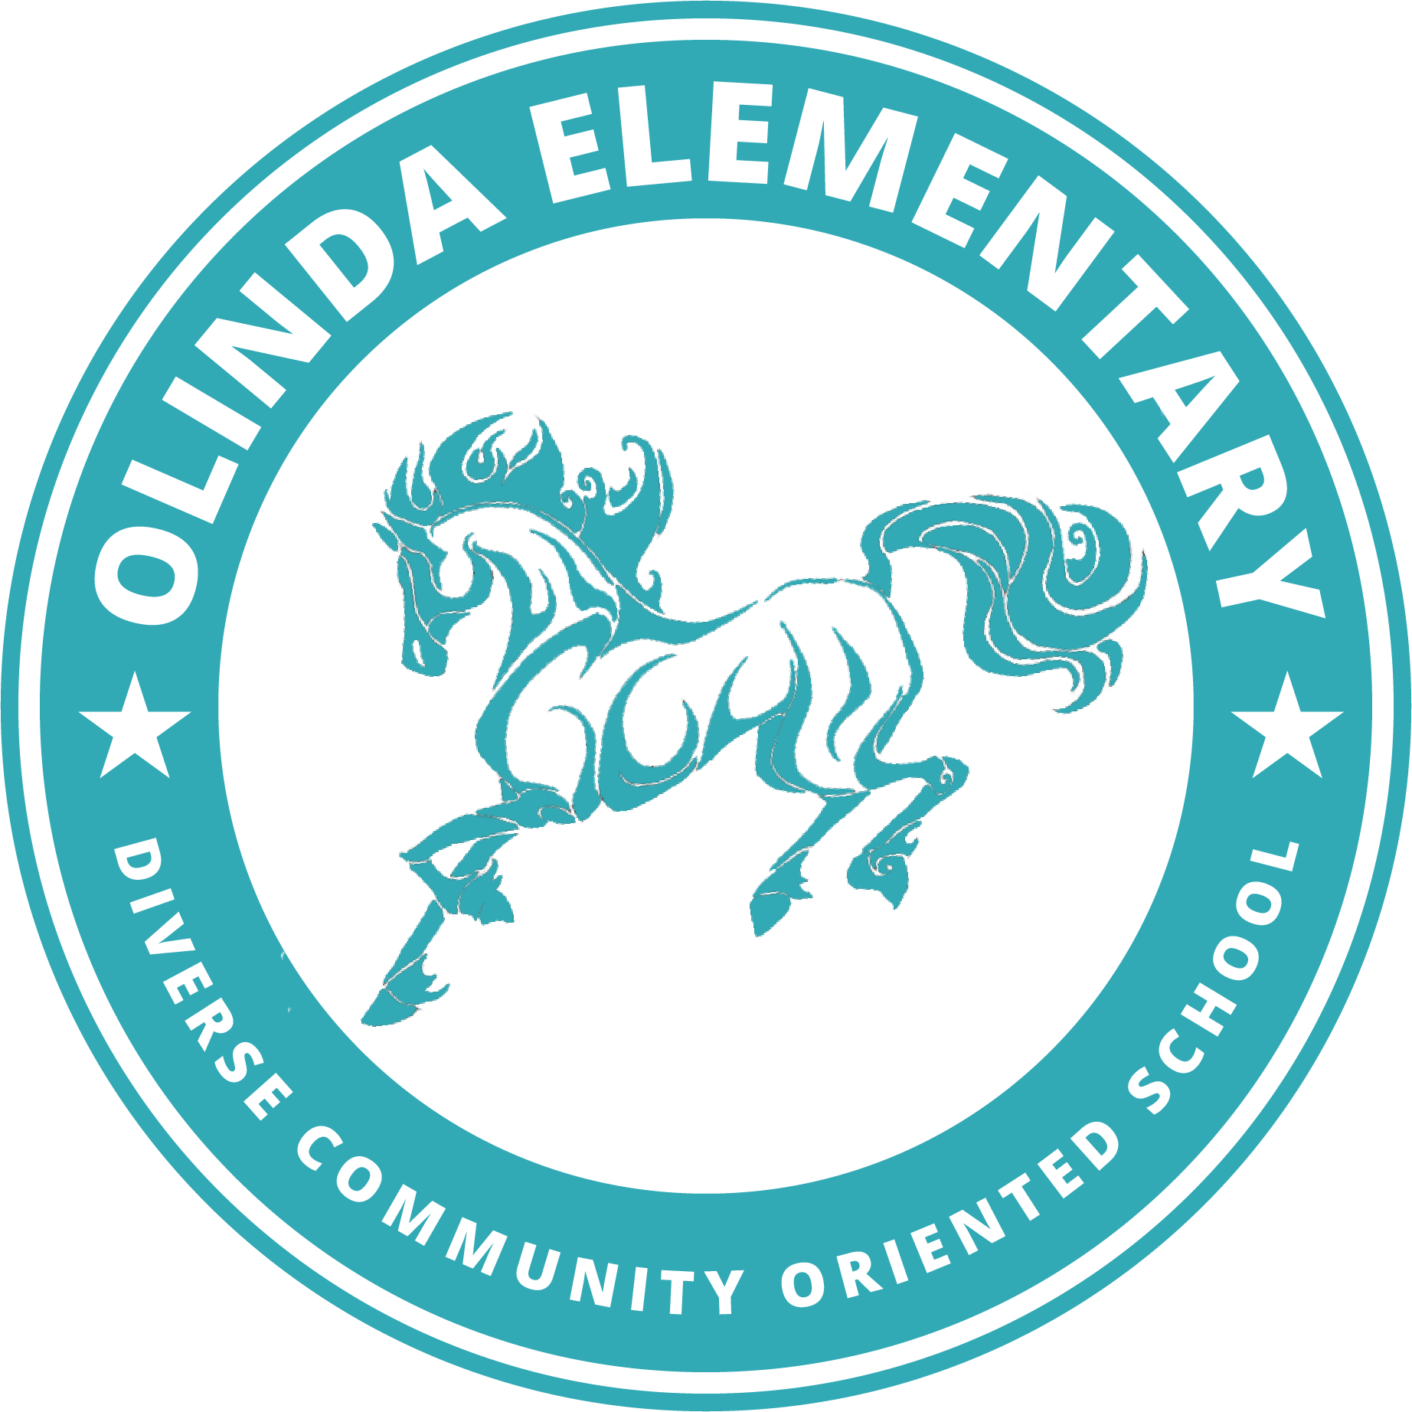August 2021

Welcome to Kindergarten! Your Teacher- Ms. Ashley would like you to each bring the following items to school with you the first day in our room 3 classroom. Students need:

* **At least two masks in their backpack in case the one they come to school in gets dirty**
  + [Crayola brand mask pack of five](https://schoolmaskpack.com/products/crayola-kids-reusable-cloth-face-mask-set-cool-colors?gclid=Cj0KCQjw6ZOIBhDdARIsAMf8YyF85AdT0MjoF6sttlMI2F-Gl-tbsdGoVPtllbDi8hjR7y7onChc-ZkaAshPEALw_wcB)
  + [Target brand mask pack of five](https://www.target.com/p/kids-39-5pk-fabric-face-masks-cat-38-jack-8482-black-pink-green/-/A-81280067?ref=tgt_adv_XS000000&AFID=google_pla_df&fndsrc=tgtao&DFA=71700000014774536&CPNG=PLA_Kids%2BShopping_Brand%7CKids_Ecomm_AA&adgroup=SC_Kids&LID=700000001170770pgs&LNM=PRODUCT_GROUP&network=g&device=c&location=9032085&targetid=aud-1281829994619:pla-896169870156&ds_rl=1246978&ds_rl=1248099&ds_rl=1246984&gclid=Cj0KCQjw6ZOIBhDdARIsAMf8YyE-Tb53K4FDEt-XBPvELVtLPC2aZ0x42E48Dg9_55Yuum01lIYcfwEaAp73EALw_wcB&gclsrc=aw.ds)
  + Masks should be washed daily- do not send your student to school in a dirty or previously worn, unwashed mask. Masks may have many sorts of decorations, or none at all- we ask that they not have logos of alcohol, profanity, or other items outlined in our student handbook as being inappropriate for school
* [**Reusable water bottle with your child’s name on it that they can manage independently**](https://www.target.com/p/minecraft-19-5oz-stainless-steel-water-bottle-zak-designs/-/A-54258971#lnk=sametab)
* Backpack
* Lunchbox if providing own lunch (WCCUSD provides free lunch to all students)

These items and the links are examples of what you will need- if you find the same item elsewhere- please don’t feel as though you must only buy at target! If you have any questions, [check the website](https://www.wccusd.net/olinda) where you will find the FAQ, links to the student handbook, the daily bell schedule, and other items!

